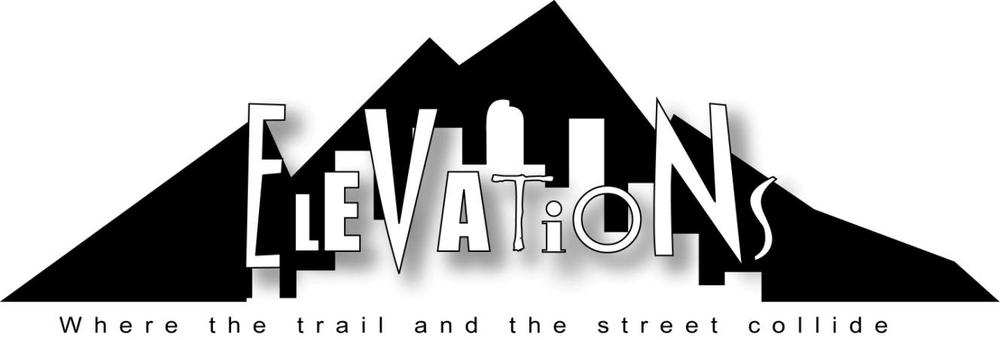

Participant Guidebook

What you can expect out of the week:

Elevations is a unique experience that combines the heights of adventure and contemplation in the wilderness with dynamic depths in the city. We design these trips to be inspiring, educational, fun, and uniquely spiritual - both in the city and the mountains.

Upon arrival, the first half of the adventure takes place in the Rocky Mountains where participants set up camp, hike, work together, experience wilderness adventures, and grow in the accelerator of God’s creation.

All will emerge from the wilderness with a new-found passion and readiness to serve and to discover adventure among people in the city. The second half of the experience takes place in the depths of Denver where the lessons of higher elevations are immediately lived out in “bleeding places” throughout the city.

Elevations is a program of Dry Bones Denver. Groups are led by the Dry Bones ministry team (see more below). Participants* will be involved in various opportunities that are focused on building genuine and meaningful relationships among homeless youth and young adults. The group will host picnics in parks, take their new friends to a movie, be a part of Dry Bones’ Thursday night event, explore the Denver underground, and much more (all activities included in Elevations fee). All of the activities will lead to new relationships where all involved encounter Christ. The combination of growth on the mountain with rich experience in the city becomes a springboard for the challenge of developing a deeply contemplative life of love and action back home.

* Participation in Elevations is limited to those over the age of 14 (or those entering the ninth grade in the fall). We suggest one Adult sponsor for every five youth participants to accompany the teens. However, there should not be more than three adult sponsors (ages 20 and older) for every 10 teenagers. Restrictions are different for college and adult groups. The program is not limited to any race, sex, or denominational affiliation.
What Your Fee Covers
Each participant is offered a discounted Participant Fee of $395 if the balance is paid in full by the date specified by your group coordinator. If the Final Balance Deadline is missed, the fee reverts to the Non-discounted Participant Fee of $425. A non-refundable deposit of $100 per participant will be due before your trip and will be applied to your overall trip fee.

The fee covers all expenses during the six days of your Elevations trip including food in the wilderness and in the city, camping equipment, and sleeping arrangements while in the city, any ministry expenses, program administration costs, activities, and materials. All other non-program expenses such as travel, lodging before or after your trip, gas, medical expenses, extra activities, etc. are not included in the fee.

Safety Is Top Priority
Elevations makes every effort to ensure the safety of each individual during the entire week. All necessary staff are current in First Aid and CPR. It is mandatory that participants respect and obey the instructions and decisions made by the staff. As would be expected, there are inherent risks involved in active camping in the wilderness. While in the wilderness and in the city, participants will only go out in groups. No one will be allowed to break away from the group alone and each group will always be accompanied by an adult sponsor.

Elevations does not carry medical insurance for its participants. Each participant is individually and financially responsible for all medical costs. The medical form included in this information package is crucial and must be filled out in order to insure proper medical care in the case of an emergency. The staff will be carrying these forms at all times. Radios and cell phones will also be carried by the staff for emergency use. In the event that the participant must come off the mountain or check into a hospital, an adult from the group will be required to accompany them at all times. All costs for lodging, food, etc. while away from the trip are the responsibility of the participant.

The Ministry Team & Dry Bones
Elevations is operated by Matt and Nikki Wallace, Robbie Goldman, Nicole Heifferon, Haley Andreades and Mark Wilson. The staff have a combination of extensive mountain guiding experience as well as experience in youth ministry and ministry to homeless youth. They have the ability and passion to help students see the spiritual reality in worldly situations. All the staff work full time with the Dry Bones ministry year-round and have worked hard to develop trust and friendships with those who live on the streets of Denver.

Dry Bones is a Christ-centered organization that ministers among homeless and runaway youth and young adults that call the streets of Denver “home”. The hundreds of “street kids” that live, gather, and survive on the 16th Street Mall area are searching for more from life. This group of “kids” ranges in ages from 12 into their late-20s. These young people are on the streets for many different reasons. Most have been abused physically, emotionally, and/or sexually, some have been thrown out of their homes by parents, others are bound by their addictions, while still others have been orphaned or have parents incapable of providing parental care. They are sometimes scary looking on the outside, but are truly some of the nicest people you will ever meet. We are all searching for Life. All Elevations participants play an active and important role in pointing Dry Bones’ friends toward Life, as they themselves seek for and discover it too.

Dry Bones’ mission is this: In the context of relationships, practicing the way of Jesus, we meet spiritual and physical needs of homeless and street-connected youth and young adults. We seek to equip and inspire all involved to relieve suffering, facilitate reconciliation, and free the heart to love.

Dry Bones is committed to developing meaningful and genuine relationship with youth that will lead to various modes of rescue and reconciliation to family, friends, and society. Your group’s contact with Denver’s homeless youth will be built upon throughout the year by the Dry Bones team and volunteers. More than anything, we desire for all Elevations participants to catch a vision that they will take home with them. Therefore, we call Elevations a Vision Trip as opposed to a Mission Trip.

The ministry team is committed to consistent attention to the group’s safety and a deep personal interest in the spiritual formation of the participants. We strive to make each trip unique to the needs of the group while carrying out our ongoing mission to serve America’s homeless youth.

Getting In Shape For Elevations
You will be doing some day hiking and camping during the first 3 days of the trip. Your physical ability should not limit you to coming on the trip. Still, if you would like to get in better shape for the hikes, some good activity ideas are:
- Walking/Jogging/Running
- Climbing stairs with a weighted pack and your hiking boots or closed toed shoes that you plan to hike in.
- Walking uphill with a weighted pack and your hiking boots or closed toed shoes that you plan to hike in.

Gear Supplied By Elevations

Gear For Each Individual:
- Sleeping Bag (5 degree mummy bag)
- Sleeping Bag Liner
- Sleeping Pad (foam)
- Large-frame Backpack

Gear For Each Crew:
- 4 Person Tents
- Stoves and Fuel
- Pots and Pans
- Cooking Utensils
- Dining/Rain Fly
- Water Treatment (Chlorine)
- First Aid Supplies (excluding medications)
- Food For 3 Meals each day
- Air Mattresses to sleep on Thursday and Friday nights in the city

The equipment issued during the week is on loan and each participant is responsible for proper care and usage. Elevations takes responsibility for the normal wear and tear on the equipment. However, participants are financially responsible for any necessary repair or replacement of equipment due to loss, misuse, abuse, or neglect.

My Packing List For The Week

In this section you will find a list of all the equipment and supplies you will need for your trip. It would be a good idea to start collecting this stuff now so you aren’t scrambling for it at the last minute. You may want to consider packing with two separate trips in mind: the three days of camping and the three days in the city.

Keep your packing down to the minimum necessities. This will make it easier for you in the wilderness and will help you have a better understanding of how the kids on the streets actually live.

IMPORTANT: Colorado’s weather in the mountains is very unpredictable. One week could bring rain, snow, hail, clouds and sunshine. Even if it’s hot at home when you are packing, please realize that it gets COLD at night while camping in the Rockies. Plan for WARM days (65-80 degrees) and COLD nights (30-40 degrees). Pack your clothes in plastic zip-lock bags to further protect them against the possibility of getting wet.
Camping Gear:
- 2 T-shirts
- 2 pairs of shorts
- 1 pair of sweat pants or fleece pants or
- 1 pair of wind pants
- 2 pair of light weight socks for around camp
- 1 pair of heavy weight hiking socks. (Wool-blend or synthetic is better than cotton.)
- Underwear (as many as you need)
- Closed toed shoes to hike in (these can be tennis shoes, but make sure the tread is good)
- A second pair of shoes (preferably tennis shoes) to wear around camp or in case the others get wet
- Warm jacket or parka with a hood
- Rain gear or QUALITY poncho with hood (Do not get the emergency ponchos because these tear and ruin too easily. Bring a good poncho or rain jacket!)
- 1 pair of thermal underwear (both top and bottom)
- Beanie or winter hat for warmth
- Warm gloves
- Warm fleece or sweatshirt
- Cup and plate (plastic or metal)
- Spoon/fork
- Daypack (a backpack similar to what you would take to school but large enough to carry food, water, gear, and jacket for day hikes)
- 1 roll of toilet paper
- Small flashlight with extra batteries
- Whistle

Personal Gear (For both on and off the mountain)
- 2 one-quart wide-mouth plastic water bottles (PLEASE bring 2!!)
- Toothbrush/toothpaste
- Hairbrush or comb
- Hand towel/ wash cloth
- Chapstick with spf 15 or more
- Sunscreen with a high block rating
- 2 large heavy duty trash bags (preferably 55 gallon – used to cover pack to keep it dry)
- Insect repellent
- Deodorant
- Small Bible
- Pen or pencil
- Sunglasses
- Personal medicines (place in a zip lock bag by themselves)
- Ziplock bags (to sort and carry the above personal gear)
- Any small/extra snacks that you may want
- Camera

NOTE: The Staff will not administer any type of medications, including aspirin, Tums, Tylenol, etc. If you need any over the counter medication, you must bring them with you. Also, all food items should be carried in ziplock freezer bags. If you are carrying individually wrapped items such as gum, jolly ranchers, etc. please remove the wrappers before you come. This will help reduce litter problems.

City Gear
- 3 T-shirts
- 3 pairs of shorts or jeans
- 3 pairs of socks
- Underwear (you figure out how many)
- Toiletries
- Comfortable shoes for walking (At least one pair of closed-toed shoes which can be the same as used for camping)
- Towel for shower
- Pillow

NOTE: Clothes should be appropriate for working. Girls, choose clothes that are tactful (no short shorts, tank tops, shirts that show your midriff, skirts, etc.) Keep in mind that the idea is not to look cute, but be able to work comfortably.

Items NOT TO BRING:

X Knives

X Firearms

X Fireworks

X Alcohol or illegal drugs

X Cell phones, electronics, etc.

Elevations Emergency Phone Numbers:

303-809-7389
(Nikki Wallace cell)

In the event of an emergency, you will be able to leave a message at the number listed above. The message will then be passed on to the participant as quickly and efficiently as possible. However, participants will not be able to be called to this phone.

